This is the static page of success story list. According to the requirement of our custom, there are 5 categories and each category contain a list of success story. A user can click the category and view different brief stories. If the user is interested in any one of the stories then he/she can click the photo or the name of the person then go to the detail page to get more information.

The aim of this static page is to implement the user story which in No.2. It should combine with login page and dynamic page to complete the whole function.

This page is a mobile friendly web page and it change itself to suit for different size of browser.
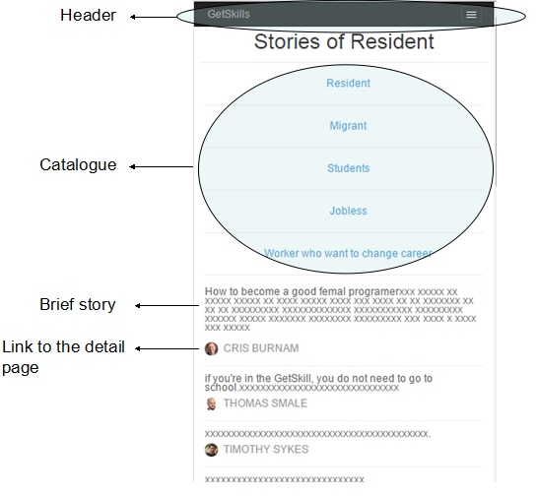
For mobile
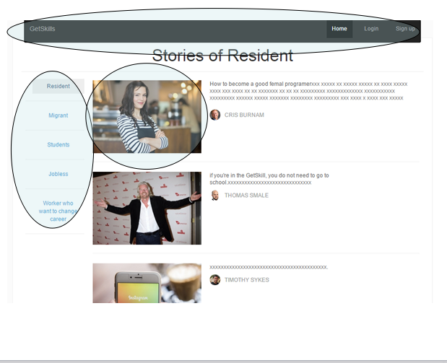
For computer

